Variable Transition Energy Lattices based on different periodic cells
with various types of dispersion suppressor

Yu. Senichevª, A. Chechenin^{b}, S. Kostromin^{c}
ªInstitute of Nuclear Physics, FZJ, D-52428, Jülich, D-52425, Germany
e-mail: y.senichev@fz-juelich.de
^{b}St. Petersburg State University, St. Petersburg, 199034 Russia
e-mail: a.chechenin@fz-juelich.de
^{c}Joint Institute for Nuclear Research
e-mail: kostromin@jinr.ru

Introduction
The “resonant” lattice [1, 2] developed to vary the transition energy is based on the resonantly correlated curvature and gradient modulations in arcs with integer tunes in horizontal or both planes. This method was first adopted for the TRIUMF and Moscow Kaon Factories project [3,4]. It was then applied in the SSC low energy booster [5], the CERN Neutrino Factory [6], and in the Main Ring of the Japanese proton accelerator research complex facility [7,8]. For the superconducting option of the High-Energy Storage Ring lattice in the FAIR project, the same principle was also applied [9]. Besides, it is one of the candidates for PS2 in CERN [10]. Due to its special features, the “resonant” lattice can also be used as a lattice with stochastic cooling where different arcs have different mixing factors, while the dynamic aperture is conserved for the whole machine [11]. At present the new project of multi-particle synchrotron NICA in JINR is considered to search for possible manifestation of signs of the mixed phase and critical endpoint in heavy ion collisions and polarized proton-proton and deuteron-deuteron beams. In this case the “resonant” structure is very much suitable, as due to variable transition energy it can give the dual properties which are meeting the requirements of acceleration of particles with different rigidity [12]. The “resonant” lattice also appears to be useful for electron machines. In synchrotron-light sources, in particular, the minimum momentum-compaction factor and the minimum modulation of the dispersion function are both simultaneously required to have a small horizontal emittance [13,14].
But it is necessary to notice, that demanded properties of lattice depend on type of cells forming the super-period and how cells are incorporated in the super-period itself. In our previous paper we always considered the super-period based on the singlet FODO cells. In this paper we consider the “resonant” lattice based on the doublet, the triplet and compare their advantages and disadvantages with the singlet cell lattice. Another subject solved in this paper is the dispersion suppressor. Earlier we always set in a suppression of dispersion by means of the integer 2π condition of radial oscillation on arc, so-called the incorporated in arc suppressor. Here we shall consider various schemes of the allocated suppressors of dispersion on the ends of arcs and compare them with incorporated ones. Furthermore we analyze different schemes of sextupoles location in the lattice based on the singlet, doublet and triplet cells and with different types of suppressor.

TRANSITION ENERGY VARIATION

With a specially correlated modulation of the quadrupole gradient 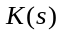 and orbit curvature 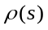, and a particular choice of betatron oscillation frequencies , the theory of “resonant” lattices makes it possible to get interrelated dispersion variations D(s) and 1/ρ(s) along the equilibrium orbit and a negative momentum compaction factor (MCF)
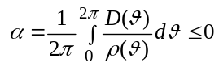 old(1)
The general principles of construction of “resonant” lattices detailed in [1,2] are based on the solution of the equation for the dispersion 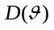 in the biperiodic structure with the cell periodicity and superperiodicity
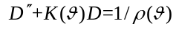 old(2)
In the optics with the horizontal tune and the superperiodical curvature modulation 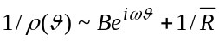, the dispersion solution is 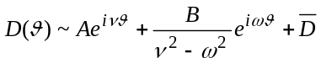. Since MCF is the average value of the function 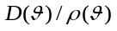, it can be written as the sum
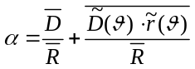 old(3),
where 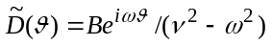 and 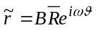 are the functions oscillating about the averages.
In an ordinary regular FODO lattice without the superperiodic modulation, the oscillating component gives 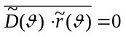, and the minimum value of MCF 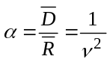 is limited by the horizontal tune .
In the “resonant” lattice, the oscillating components contribute the term 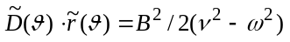, which in the case 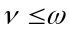 can result in a negative MCF. The same can be shown for the gradient modulation 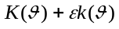. Here, we omit the long intermediate computations and quote the final formula for the case when the functions of gradients 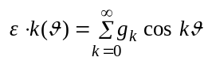 and/or orbit curvature 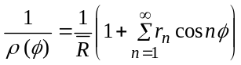 are jointly modulated:
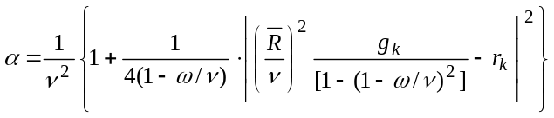, old(4)new(1)
where 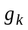 and are fundamental harmonics producing the maximum effect on MCF.
Indeed, if both the gradient function and the orbit curvature function are modulated with identical frequency, the second term in (4) may make an appreciable negative contribution to MCF provided that the value 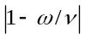 is small and .
In addition, from (4), there follows an obvious condition of antiphase modulation of the gradient and curvature function 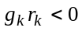, which allows correlated variation of the momentum compaction factor with the aid of these functions. Based on the above reasoning, the “resonant” lattice method with simultaneous orbit curvature and quadrupole gradient modulation with an identical frequency of the fundamental harmonics and an approximately identical contribution of both modulations to the final value of the momentum compaction factor is most effective. From (4) it is easy to derive the following equality for an arbitrary fundamental harmonics and giving 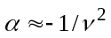:
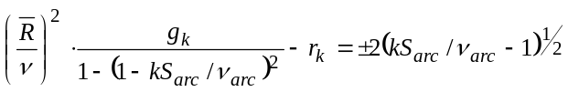 old(5)
and
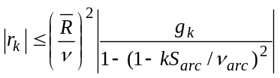 old(6)
Apparently, that if we modulate one of functions the modulation value should be double.

MICROSTRUCTURE OF THE “RESONANT” LATTICE

In common case there are two types of lattices used in accelerators with inserted straight sections, the so-called circular lattices with S identical superperiods and the lattice consisting of arcs with S_{arc} superperiods per arc separated by straight sections. In the former lattices the momentum compaction factor completely coincides with its value for one superperiod. In the lattices consisting of arcs with S_{arc} superperiods of length L_{s} and separated by straight sections of length L_{str}, the momentum compaction factor for the entire accelerator α_{total}  and for a superperiod α_{s} are related by the equation
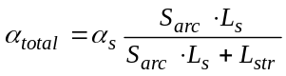. old(7)new(2)
Thus, knowing the momentum compaction factor for one superperiod, one can easily find its value for the entire accelerator. Since the straight sections do not affect essentially on the momentum compaction value, just as a coefficient in expression (7), we concentrate on the arc structure for the most part.
The arcs are based either on the regular cell-periodical structure or on superperiods. A superperiod is usually formed by varying parameters of a regular lattice consisting of singlet FODO cells, doublet FDO cells, or triplet FDFO cells (F is the focusing quadrupole, D is the defocusing quadrupole, and O is the drift space for bend magnet location), each having its advantages and drawbacks. Figure 1 shows the microstructure of one super-period based on singlet, the doublet and triplet. You can see that in first option in each space between quadrupoles one bend magnet is placed and in two other ones we have two magnets in each gap. However from the point of view of realization of focusing force modulation all options are identical, since it does not depend on the cell structure.

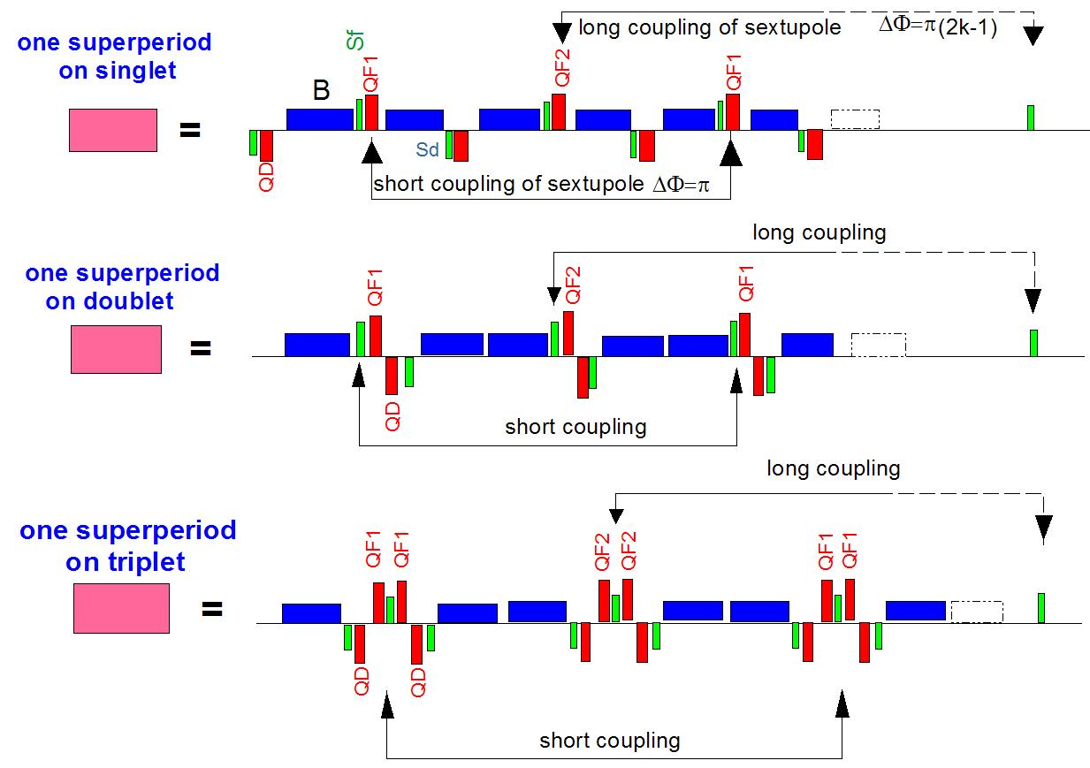
Figure 1: Microstructure: super period based on singlet, doublet and triplet

Nevertheless we should mention, that for each of options there is own scope of usage. So for example, considering the chromaticity compensation requirement, the FODO lattice is most preferable because the other two lack good separation of the horizontal and vertical β-functions, which results in a decreased efficiency of the sextupoles and accordingly in a decreased dynamic aperture. In addition, the FODO superperiod with mirror symmetry about its center provides most favorable conditions for independent control of the betatron frequencies, chromaticity in both planes, and momentum compaction factor, which makes a lattice like this superior to any other.
In the same time on belief of the experts working with the heavy ion machines (FAIR in GSI) the structure based on doublet has greater efficiency at separation of particles with different mass-charge ratio. Concerning of the triplet structure it gives smoother envelope behavior and provides the lower intra-beam scattering, but this feature has to be traded off together with all other [12].
We have studied all structures and we can tell, that from the point of view of realization of high value of transition energy all structures are almost equivalent. In figure 2 examples of calculations of these structures of one cell and one superperiod for the same values of transition energy are shown. You can see that in spite of different envelope on cells the averaged dispersion has similar character along the superperiod.

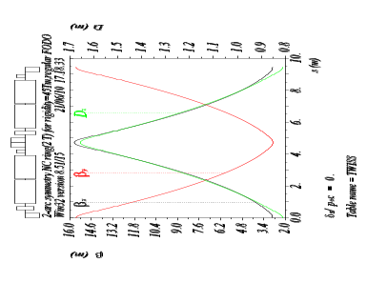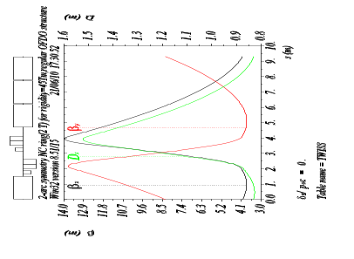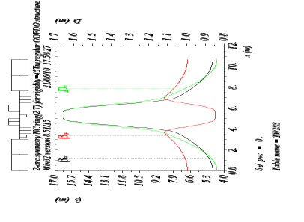
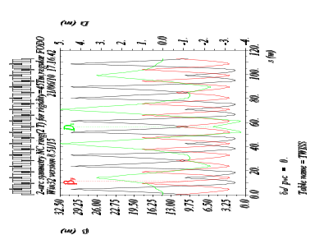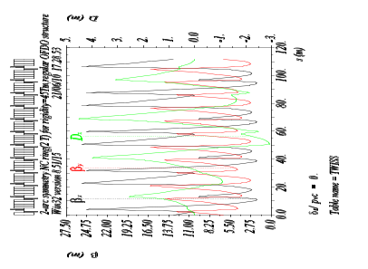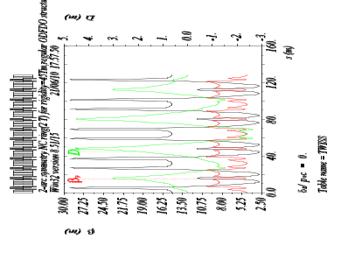
(a) (b) (c)

Figure 2: Twiss parameters for FODO (a), FDO (b) and FDFO (c)

The number of cells in a superperiod N_{cell} is dictated by the required phase advance of radial oscillations. Following the theory of “resonant” lattices, we should try to construct a lattice with the horizontal tune ν  as close to the number of superperiods as possible. In this case, the phase advance of horizontal oscillations per cell will be about 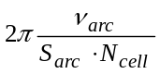. At the same time it is known that from the point of view of minimization of the β-functions for a cell the phase advance of radial oscillations should fall within the range 60⁰–100⁰. Thus, in a lattice with the fundamental harmonic of the modulation of the superperiod parameters k = 1 and with ν_{arc}< S_{arc} the number of cells turns out to be 3–5 per superperiod. Since an increase in the number of cells requires greater splitting of the superperiod and entails an increase in the number of magnetic optical elements, we exclude the five-cell option from consideration and confine ourselves to analysis of a superperiod comprising 3–4 cells.
Obviously, strict periodicity of cells does not make it possible to get the required value of the momentum compaction factor, which is fixed by the value of the horizontal betatron frequency in this case. According to the theory of “resonant” structures, either modulation of the lens gradients or modulation of the orbit curvature, or simultaneous modulation of both functions is introduced to get the required momentum compaction factor [1, 2]. As you can see figure 2 shows a superperiod made up of three periodical cells with gradient modulation alone and mirror symmetry about the center, where two quadrupole families form the required fundamental harmonic k = 1. The arc is supposed to consist of 4 superperiods with almost the same total length. However, to get the required high gamma-transition this modulation method requires a great change of the field in the quadrupoles. Note that strong modulation of the gradients leads to a considerable increase in β-functions, and chromaticity of the entire accelerator, which results in a reduced dynamic aperture.
In case of the curvature-varying lattices β-functions became smaller and chromaticity is kept lower. Figure 3(a) shows example of the superperiod with modulated curvature by “missing magnet” in center of superperiod PS2 machine. But unfortunately, the orbit curvature modulation method does not always provide the required value of gamma-transition.

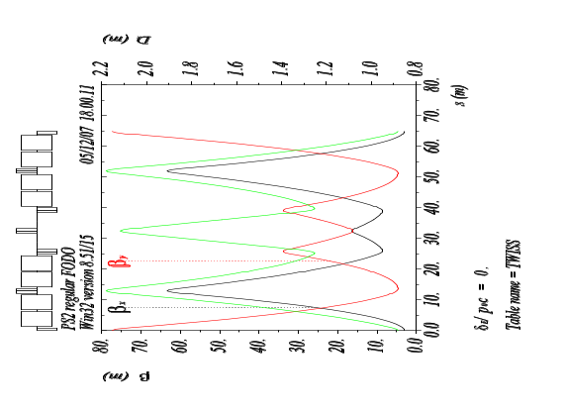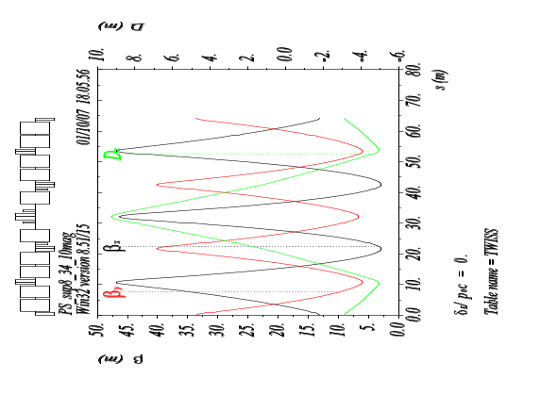
- (b)

Figure 3: Superperiod with orbit curvature modulation

Therefore the only possibility is a modulation of both the orbit curvature and the quadrupole gradients to get the required momentum compaction factor (fig. 3b). The former method allows controlling the momentum compaction factor with the minimum increase in the β_{x} function and D_{x} and, compared with gradient modulation lattices, does not require strong sextupoles for chromaticity correction. However, the gradient modulation method is the only method allowed the momentum compaction factor of the periodic lattice to be varied, which one plays crucial role in some machine, for instance in the dual structure for NICA [12].

MACROSTRUCTURE OF THE “RESONANT” LATTICE

The macrostructure basically is defined by how we build a dispersion suppressor and as we compensate nonlinear influence of sextupoles. Following the later there are three possible versions (see figure 4 a,b,c).
In the first version (fig. 4a) the suppressor is incorporated in arcs, and a dispersion zeroing due to integer 2π of horizontal phase advance. This means that the phase advance in one superperiod should be 2πν_{arc}/S_{arc}. On the other hand, for MCF to be controlled, it is reasonable to take the minimum possible difference 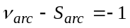. Thus, many ratios exist between S_{arc} and ν_{arc}: (4:3), (6:5), (8:7), (10:9), … It is obvious that in all ratios, the number of superperiods S_{arc} is taken to be even, while the betatron oscillation frequency takes on odd values. In this case, the phase advance of the radial oscillations between the cells located in different superperiods and separated by S_{arc}/2 superperiods is
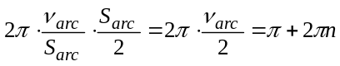, old(8)
which corresponds to the condition of first-approximation compensation for the nonlinear effects of sextupoles located in these cells. This remarkable property also applies to higher multipoles in any element. This coupling through S_{arc}/2 number of super periods will be referred to as the long coupling. In the first version the sextupoles are placed on arcs in all superperiods, and the condition of compensation is fulfilled for all of them. Advantage of such structure is absence of a special suppressor of a dispersion. However it leads to additional growth of a dispersion in the center of an arc due to arch modulation of dispersion.
To exclude the last in second version the special suppressors of a dispersion at edges of an arc are entered. In this version on a periodic part of an arc the dispersion has no modulation because of absence of the requirement to have a zero dispersion at its edges. To keep properties of a dispersion suppressor in wide region of energy the suppression is done by variation of strength in two quadrupoles of suppressors. Sextupoles are installed only in a periodic part of arc in every superperiod and they are absent in the dispersion suppressors in order to avoid a violation of the sextupole compensation condition. In this version at the 90⁰ advanced phase per cell we have two types of sextupole compensation: the long coupling and the short coupling acting through two cells with total phase advance 180⁰. The general advantage of these two versions is the possibility of a transition energy variation: in the first due to variation of gradients of quadrupoles on whole arc, in second version on its periodic part only.
If to refuse from two important features, a variation of critical energy and dispersion suppressors working in wide energy region, the number of superperiods per an arc may be arbitrary, and dispersion suppressors are constructed by a principle half- or missing-magnets. In the third version (fig. 4c) the dispersion suppressors based on a principle "half-magnet" are located on the ends of arcs. The periodic part of arc can be shorter, which one exclude the sextupole long coupling. Nevertheless the condition of the mutual paired compensation sextupoles forces us to have them outside arcs.

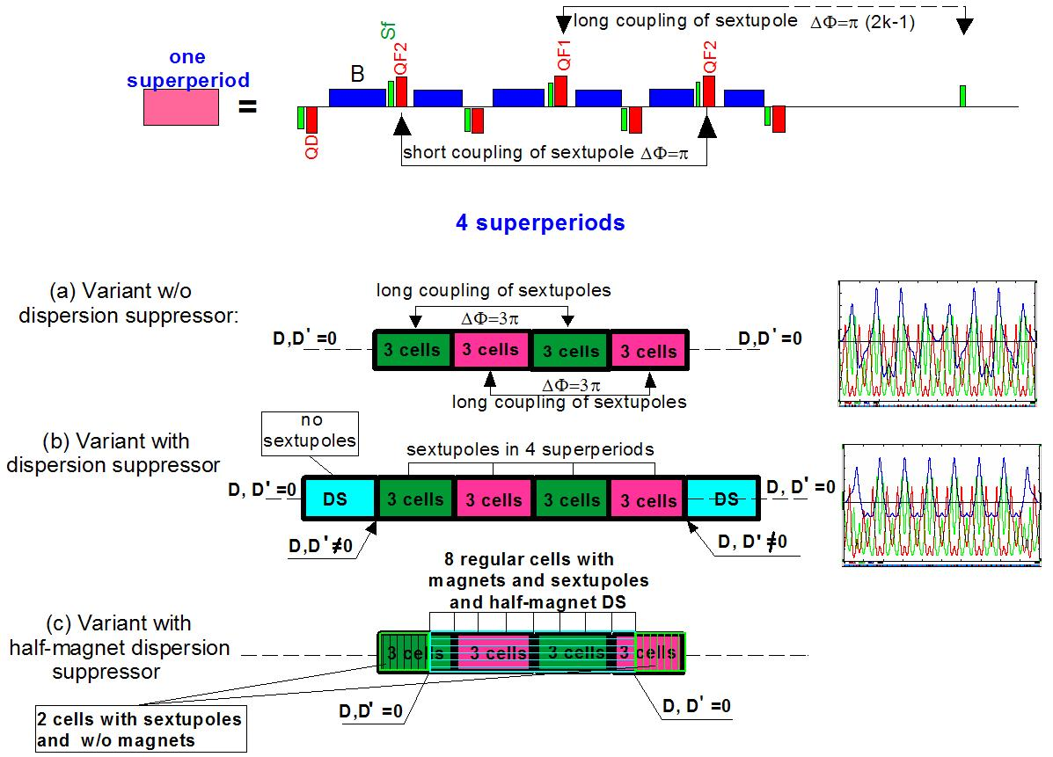

Figure 4: Macrostructure based on different type of dispersion suppressor

NONLINEAR TUNE SHIFT CONTROL

In case of great chromaticity contribution from the straight section a method of the second order non-linearity compensation has to be provided. Taking into account nonlinear terms no higher than 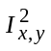, the average Hamiltonian in the vicinity of the resonance can be written as:
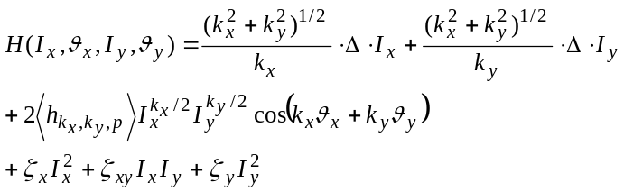, old(9)
where is the detuning from resonance 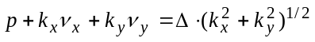. The coefficients 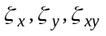 determine the nonlinear tune shift. In the first order of the perturbation theory, the nonlinear tune shifts arise due to the octupoles only, but in the second order, the sextupoles also contribute to the nonlinear tune shift:
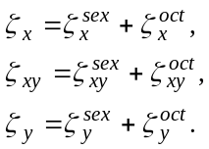 old(10)
Let us consider the Hamiltonian of the system near the third-order resonance in one of the planes. In the system without the friction force, there are two types of fixed points. The fixed point 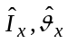 is the saddle, if the roots of the characteristic equation are real and it is the centre when the roots are imaginary. The point itself is derived from the equations:
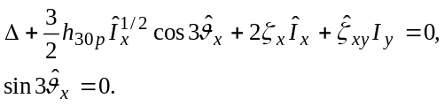 old(11)
The latter gives plenty of combinations with the fixed points depending on the ratio between the parameters 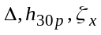 and 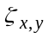. The influence of nonlinearity is specified by the discriminant in the expression:

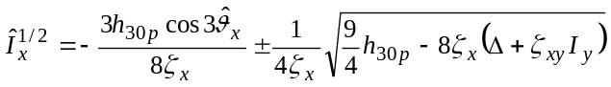 old(12)new(3)
Substituting in the characteristic equation, we can define what kind of fixed point this is. From the lattice design point of view, there are three interesting cases: 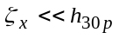; 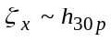 and 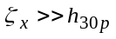.

In the “resonant” lattice, the value of 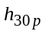 is effectively suppressed. Therefore when the nonlinearity remains under control and strong, we get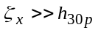. It is obvious from (12) that if the sign of the detuning coincides with the sign of the tune shift 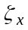, the discriminant is negative and the system has only one centre at 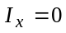. Therefore, this case corresponds to the maximum stable region and the lattice with these features is the most promising.
In principle, the sextupole nonlinear tune cannot be controlled after the sextupole location has been fixed. Therefore, the sign of total chromaticity is controlled by the octupoles, which are located in the multi-pole correctors. Thus, after chromaticity correction, the nonlinear tune shift is measured and then using the correcting octupole, we adjust the required sign and value of the nonlinear tune shift, as described in our previous paper.

“RESONANT” LATTICE APPLICATION

The most important application of the “resonant” lattice is the magneto-optic structure without 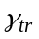crossing. Based on the above reasoning, the “resonant” lattice method with simultaneous orbit curvature and quadrupole gradient modulation with an approximately identical contribution of both modulations to the final value of the momentum compaction factor is most effective. From (4) it is easy to derive the following equation for arbitrary fundamental harmonics and giving 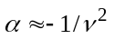 and 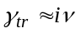
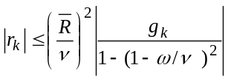 old(13)

Another application of the “resonant” lattice is as an advanced lattice for stochastic cooling. It is known that to intensify the stochastic cooling process, the mixing factor between the pick-up and kicker should ideally be as large as possible. On the other hand, in the case of mixing between the kicker and pick-up, the mixing factor should be smaller. It can be seen that the “resonant” lattice has a remarkable feature: the gradient and the curvature modulation amplify each other when they have opposite signs, while they can compensate for each other when they have the same signs (see formula 4):
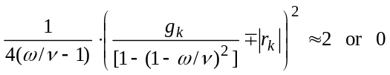 (14)
Thus, in such a lattice, we can make two arcs (fig. 5) with different slip factors: 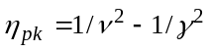; 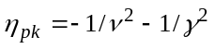 In case 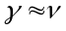, one of the arcs is isochronous when the slip factor is 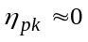 and the other slip factor is 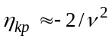.
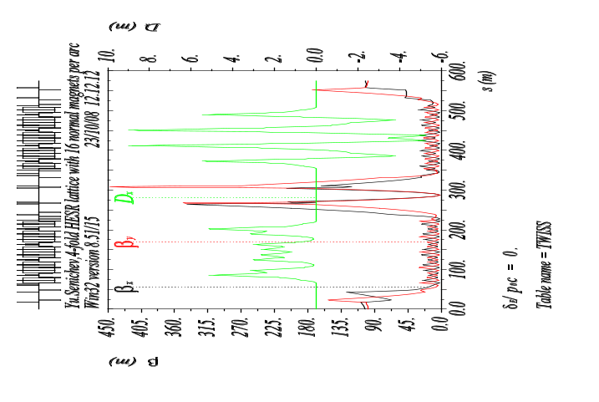
Figure 5: The advanced HESR lattice with two different arcs

Third application of the “resonant” lattice is the dual structure of NICA [12]. To meet the NICA requirements to work with different magnetic rigidity beams Au-ions in range 1÷4.5 GeV/u and with proton 6÷13 GeV we consider the possible lattice with variation of both the beam energy and the transition energy. Such lattice has to have the feature of duality, when the same optic structure provides the minimum IBS heating for Au-ions and the increased transition energy for proton modes. In the proton mode the number of cells in one superperiod N_{cell} and number of superperiods S_{arc} per arc is dictated by the required phase advance of radial oscillations. Following the theory of resonant lattices, we construct a lattice with the horizontal frequency on arc ν_{arc} as close to the number of superperiods S_{arc} as possible keeping them both integers. In the Au option any modulation of gradient leads to IBS heating. Therefore taking all arguments we choose the arc with 12 FODO cells grouping in 4 superperiods for the proton by the gradient modulation and remaining the regular structure (no modulation) for Au-ions (see fig.6a,b). Transition from one option to another is done just by gradient change in two focusing quadrupole families on arcs and then matching with the straight sections.

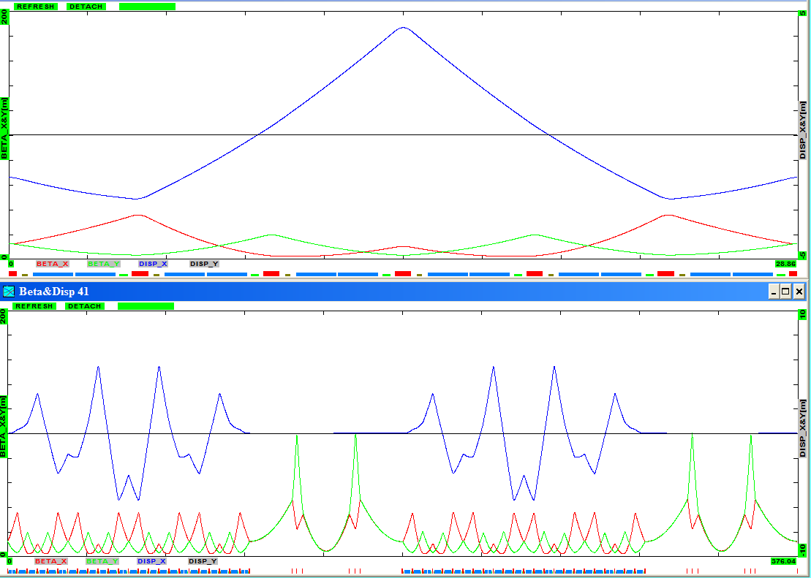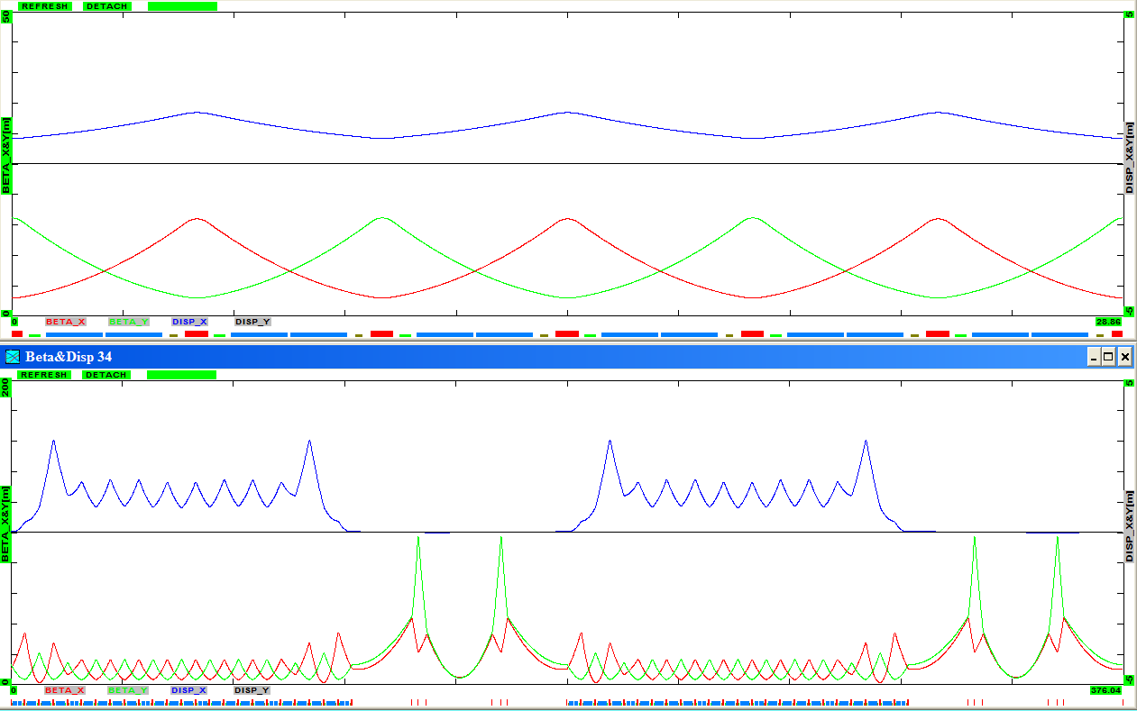

(a) (b)

Figure 6: Dual lattice of one superoeriod and arc tuned for protons (a) and Au⁷⁹⁺ (b) beams

The fourth application of the “resonant” lattice is the synchrotron light source. Since the horizontal emittance depends upon the horizontal dispersion function 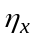, as 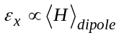, where 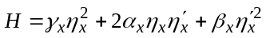, the lattice with small electron emittances therefore requires the smaller dispersion function and, as a consequence, the stronger sextupoles are needed in order to correct the chromaticity. At the same time, it is well known that the sextupoles dramatically decrease the dynamic aperture due to their nonlinear action. In this case, we can use the “resonant” lattice where the sextupolar terms are aimed to be smaller, and each pair of sextupoles have the same effect as one octupole. The nonlinear tune then plays the role of a stabilizing factor. Such a lattice has to be classified as a special lattice [13], since the sextupolar term is effectively suppressed, but the nonlinearity remains under control and strong. This method together with the smallest emittance results in a large dynamic aperture. For comparison, the dynamic aperture of a modified circular Chasman-Green lattice with the same number of sextupole families is smaller by a factor of four.
Furthermore, there is currently much interest in magnetic lattices, which can be operated over a range of momentum compaction factors. This provides several advantages and the possibility of working without sextupoles.

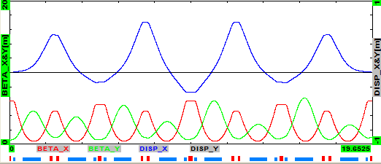

Figure 7. The arc lattice with vatiable momentum compaction factor

Figure 7 shows the arc with a tuneable momentum compaction factor. In this lattice, one cell is formed by two adjoining cells, and each second focusing quadrupole is replaced by a short combined function bend magnet with positive gradient BG(G>0). As a result, the arc consists of four cells and each half cell has a structure: trim QF+short BG(G>0)+long BG(G<0)+QF. The trim quadrupole is used for fine tuning. The dispersion function is equal to zero at the ends of the arc. This is automatically caused by an integer tune number for the arc. The matching sections are not needed. Due to the low beta function and zero dispersion function in the middle of each long bending magnet, the electron beam emittance has a rather low value [14].

CONCLUSION
We have developed a multi-application “resonant” lattice based on singlet, doublet and triplet with the following distinguishing features: ability to achieve the negative momentum compaction factor using resonantly correlated curvature and gradient modulations; gamma transition variation in a wide region from 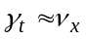 to 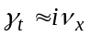 with quadrupole strength variation only; dispersion-free straight section; independent optical parameters of arcs and straight sections; two families of focusing and one of defocusing quadrupoles; separated adjustment of gamma transition, horizontal and vertical tunes; convenient chromaticity correction method using sextupoles; first-order self-compensating scheme of multipoles and a large dynamic aperture.

REFERENCES
[1] Yu. Senichev and A. Chechenin, Construction of “Resonant” Magneto-Optical Lattices with Controlled Momentum Compaction Factor, Journal of Experimental and Theoretical Physics, 2007, Vol. 105, No. 6, pp. 1141–1156
[2] Yu. Senichev and A. Chechenin, Theory of “Resonant” Lattices for Synchrotrons with Negative Momentum Compaction Factor, Journal of Experimental and Theoretical Physics, December 2007, vol. 105, No. 5, pp. 1127–1137
[3] N. Golubeva, A. Iliev, Yu. Senichev, The new lattices for the booster of Moscow Kaon Factory, Proceedings of International Seminar on Intermediate Energy Physics, v. 2, p. 290, Moscow, 1989
[4] U. Wienands, et al., A racetrack lattice for the TRIUMF Kaon Factory Booster, HEAC XV, Hamburg, 1992
[5] E. Courant et al., Low Momentum Compaction Lattice Study for the SSC Low Energy Booster, PAC, p. 2829, San-Francisco, 1991
[6] H. Schönauer, et al., A slow-cycling proton driver for a Neutrino Factory, Proceedings of EPAC, p. 966, Vienna, 2000
[7] Yu.Senichev, A «resonant» lattice for a synchrotron with a low or negative momentum compaction factor, KEK Preprint 97 40, 1997
[8] Y. Ischi, et al., Lattice design of JHF synchrotrons, APAC, Tsukuba, 1998
[9] Yu. Senichev, et al., Lattice Design Study for HESR, EPAC, Lucerne, 2004, p.653
[10] Yu. Senichev, The lattice with imaginary γ-transition for the CERN proton synchrotron PS2, CERN-2007-005, BEAM-07, p. 171
[11] Yu. Senichev, The advanced HESR lattice for improved stochastic cooling, COOL-07, Bad Kreuznach, Germany, 2007, p.102
[12] S.Kostromin et al.,Lattice of NICA collider Rings, IPAC, Kyoto, Japan, 2010, pp. 690-692
[13] Yu. Senichev, The proposed racetrack lattice for the synchrotron light source “Astrid II”, EPAC, Stockholm, 1998, pp. 642
[14] Yu. Senichev, Low periodicity lattice for Third generation synchrotron light sources: avoidance of dynamic aperture reduction by sextupole compensation, PAC, New York, 1999, p. 2442

